五子棋记谱纸 五子棋记谱纸

比赛名称：_____________________________________ 比赛名称：______________________________________

比赛日期：_____________________________________ 比赛日期：______________________________________

比赛轮次：_____________________________________ 比赛轮次：______________________________________

黑方:______________________用时:________________ 黑方:_______________________用时:________________

白方:______________________用时:________________ 白方:_______________________用时:________________

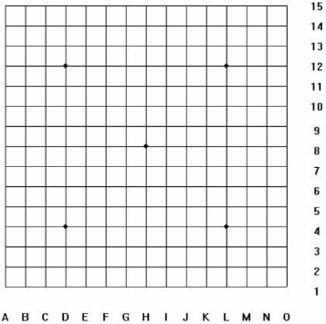开局：________打点：___________________________ 开局：_________打点：___________________________

交换（Y/N）：___胜方/平局：______________________ 交换：（Y/N）：___胜方/平局：______________________

步数：____棋手签字：____________________________ 步数：____棋手签字：_____________________________